How does AWS Lambda secure my code?

AWS Lambda **stores code in Amazon S3 and encrypts it at rest.** AWS Lambda performs additional integrity checks while your code is in use.

What if I need scratch space on disk for my AWS Lambda function?

Each Lambda function **receives 500MB of non-persistent disk space** in its own /tmp directory.

Can I use threads and processes in my AWS Lambda function code?

Yes. AWS Lambda allows you to use normal language and operating system features, such as creating additional threads and processes. Resources allocated to the Lambda function, including memory, execution time, disk, and network use, must be shared among all the threads/processes it uses. You can launch processes using any language supported by Amazon Linux.

 What restrictions apply to AWS Lambda function code?

Lambda attempts to impose as few restrictions as possible on normal language and operating system activities, but there are a few activities that are disabled: Inbound network connections are blocked by AWS Lambda, and for outbound connections only TCP/IP sockets are supported, and ptrace (debugging) system calls are blocked. TCP port 25 traffic is also blocked as an anti-spam measure.

How are compute resources assigned to an AWS Lambda function?

In the AWS Lambda resource model, you choose the amount of memory you want for your function, and are allocated proportional CPU power and other resources. For example, choosing 256MB of memory allocates approximately twice as much CPU power to your Lambda function as requesting 128MB of memory and half as much CPU power as choosing 512MB of memory. You can set your memory in 64MB increments from 128MB to 3GB.

How are events represented in AWS Lambda?

Events are passed to a Lambda function as an event input parameter.

How do I coordinate calls between multiple AWS Lambda functions?

You can use [AWS Step Functions](https://aws.amazon.com/step-functions/) to coordinate a series of AWS Lambda functions in a specific order. You can invoke multiple Lambda functions sequentially, passing the output of one to the other, and/or in parallel, and Step Functions will maintain state during executions for you.

What is Lambda@Edge?

[Lambda@Edge](https://aws.amazon.com/lambda/edge/) allows you to run code across AWS locations globally without provisioning or managing servers, responding to end users at the lowest network latency.

How do I allow my AWS Lambda function access to other AWS resources?

You grant permissions to your Lambda function to access other resources using an IAM role. AWS Lambda assumes the role while executing your Lambda function, so you always retain full, secure control of exactly which AWS resources it can use.

*Can a single Lambda function have access to multiple VPCs?*

*No. Lambda functions provide access only to a single VPC. If multiple subnets are specified, they must all be in the same VPC. You can connect to other VPCs by peering your VPCs.*

Can Lambda functions in a VPC also be able to access the internet and AWS Service endpoints?

Lambda functions configured to access resources in a particular VPC will not have access to the internet as a default configuration. If you need access to external endpoints, you will need to create a [NAT](http://docs.aws.amazon.com/AmazonVPC/latest/UserGuide/vpc-nat-gateway.html) in your VPC to forward this traffic and configure your security group to allow this outbound traffic.

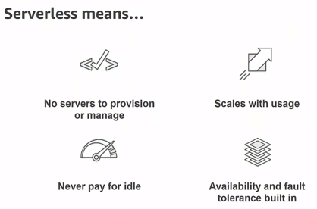

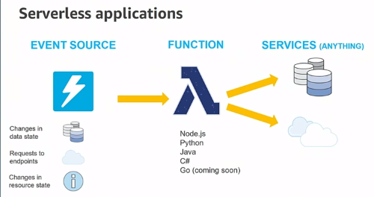

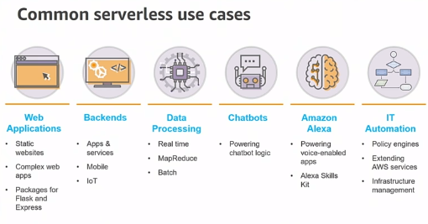

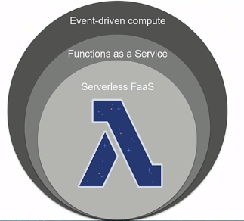

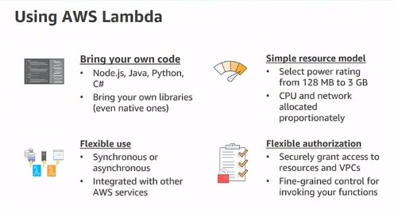

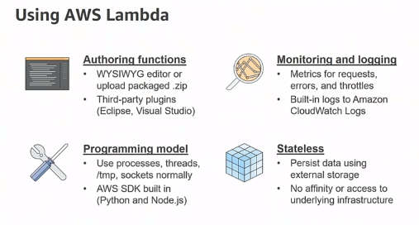

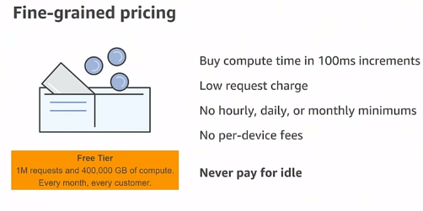

Push – Api gateway

Event based..

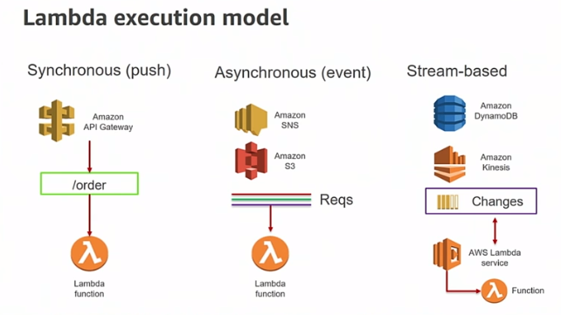

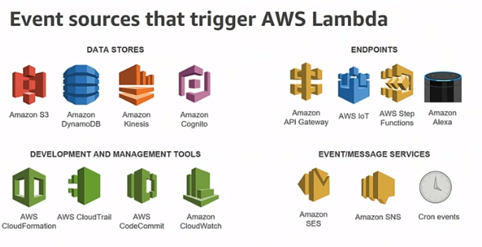

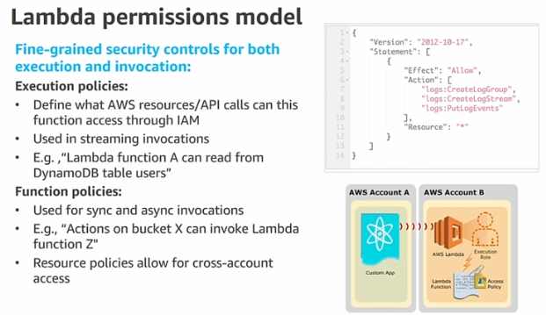

Advantage of using:

Take advantages of gateway, don’t have to write code to do it..

* Authentication, authorization
* Throttleling
* etc

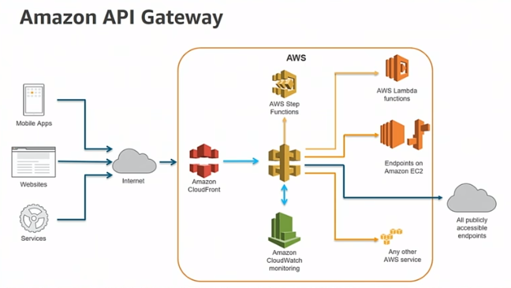

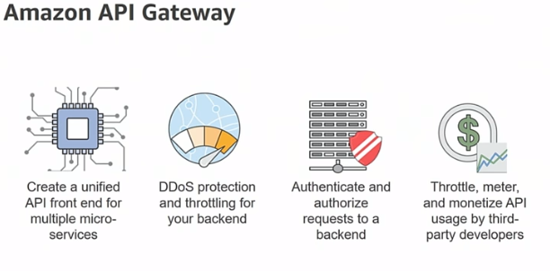

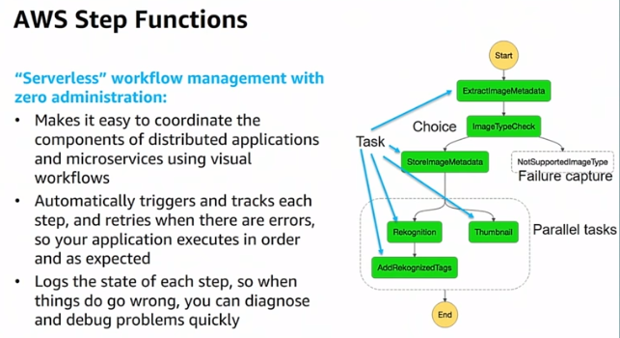

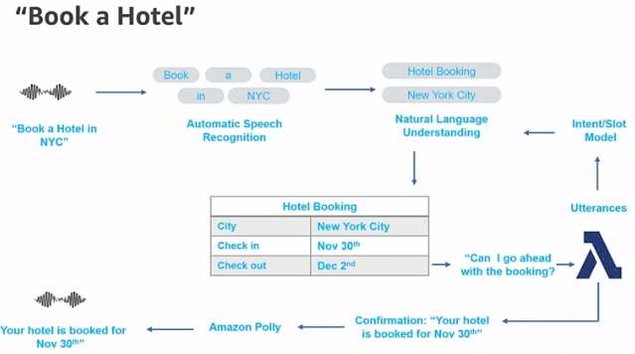

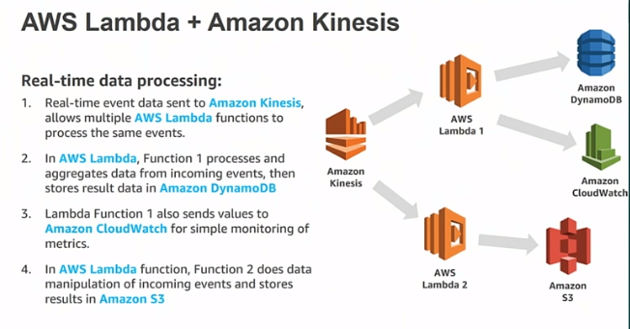

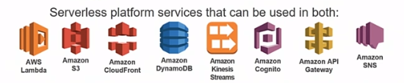

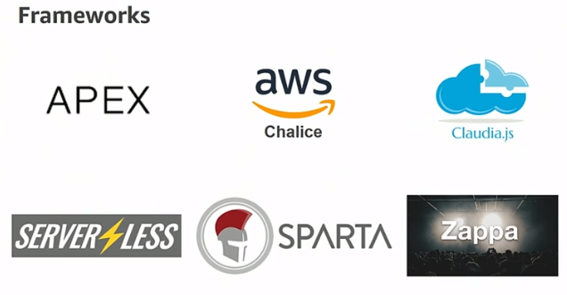

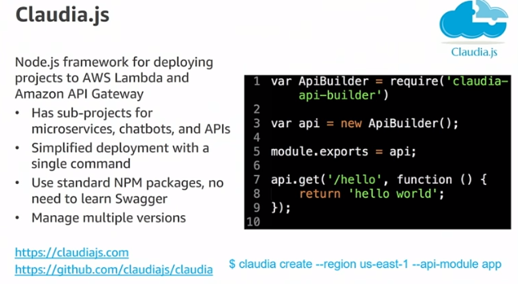

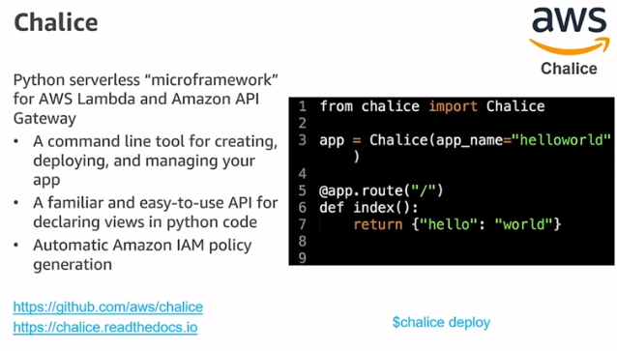

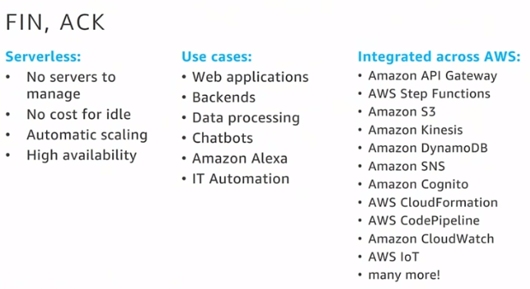

Thanks & Regards,

Shantaram Vernekar

**From:** Shantaram Vernekar   
**Sent:** Saturday, July 28, 2018 5:11 PM  
**To:** Shantaram Vernekar <[shantaram_vernekar@persistent.com](mailto:shantaram_vernekar@persistent.com)>; 'shantaram.vernekar@citi.com' <[shantaram.vernekar@citi.com](mailto:shantaram.vernekar@citi.com)>  
**Subject:** AWS - Lambda

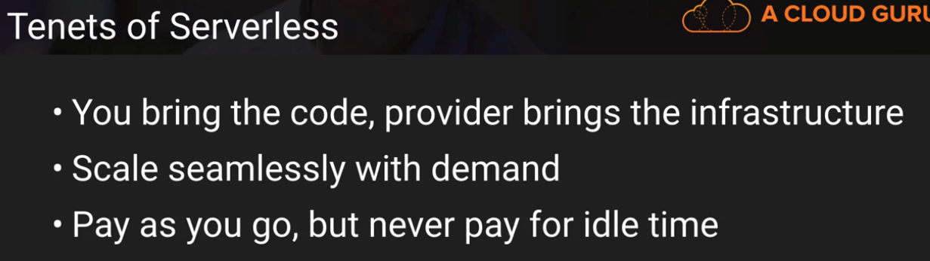

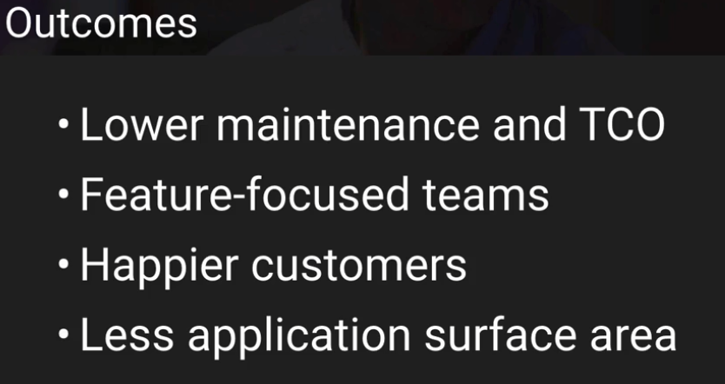

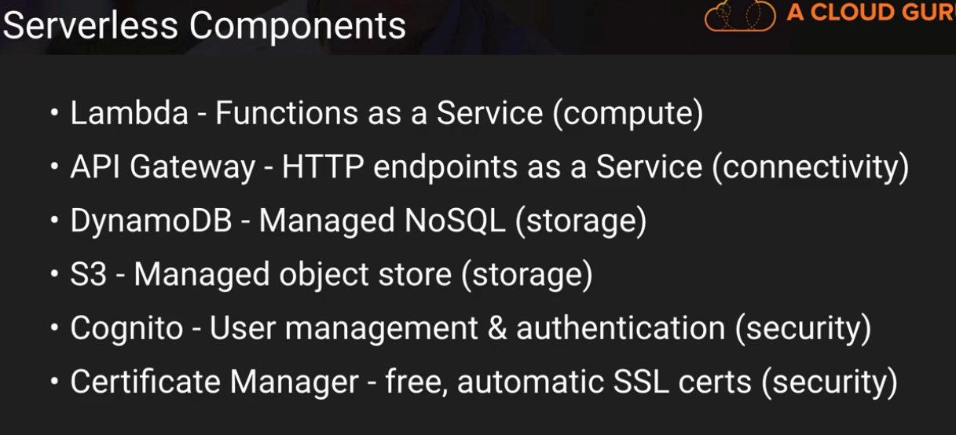

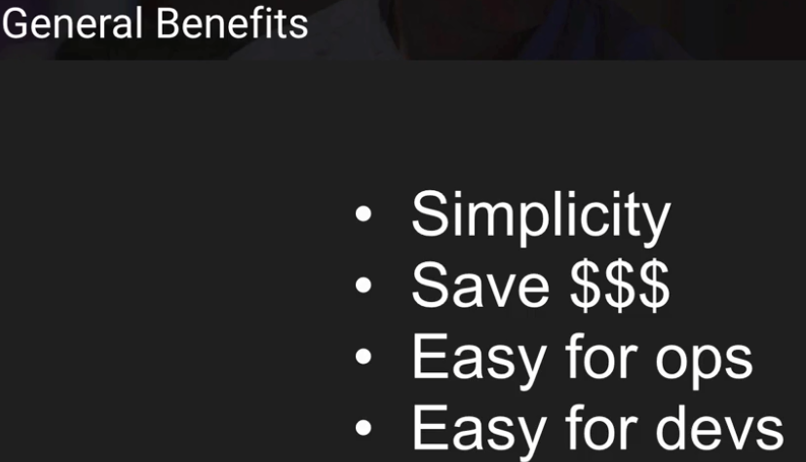

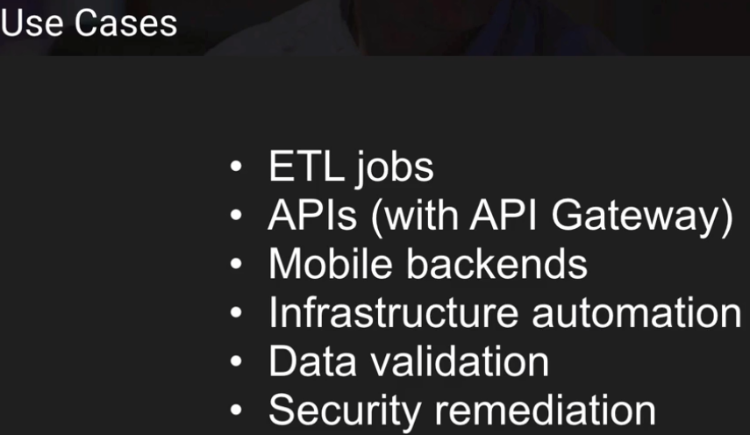

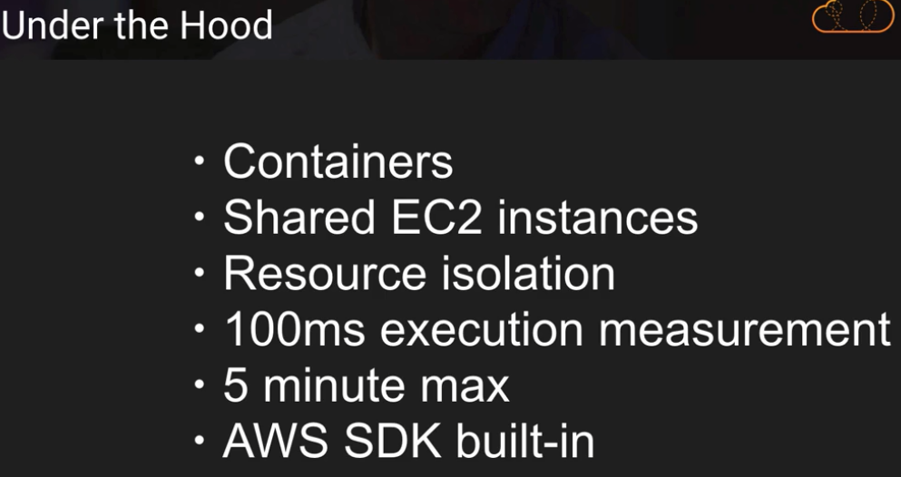

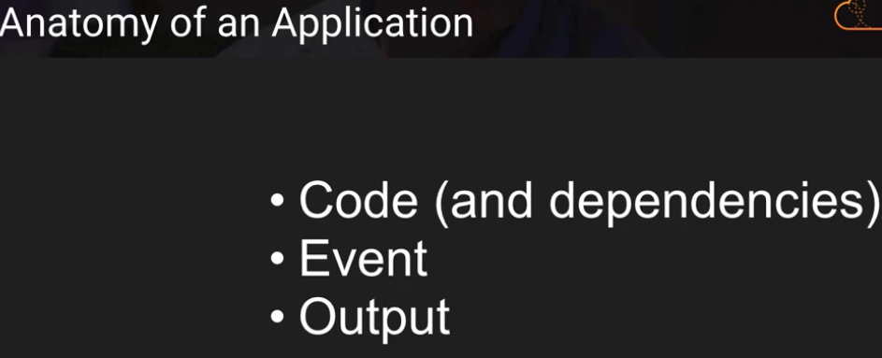

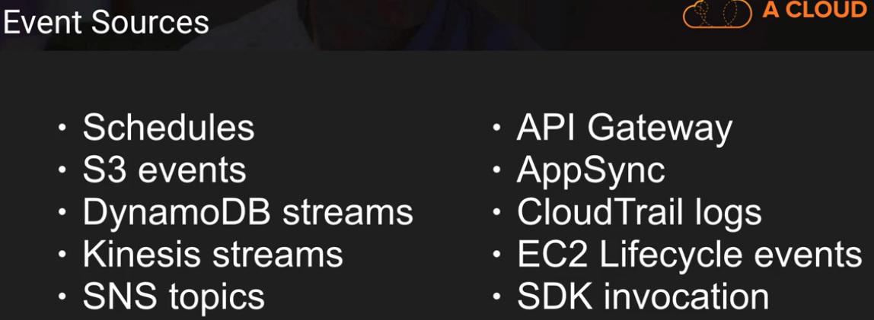

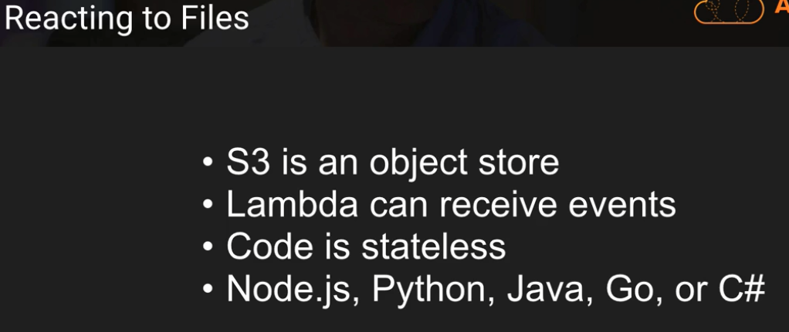

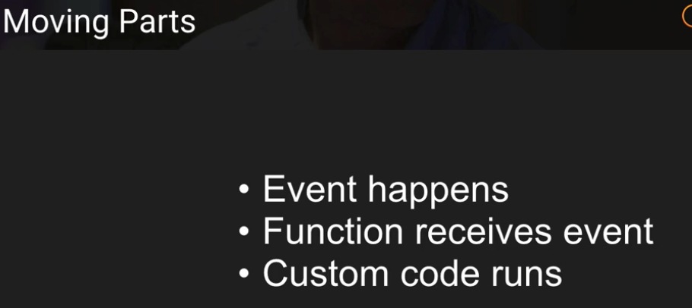

No need to poll

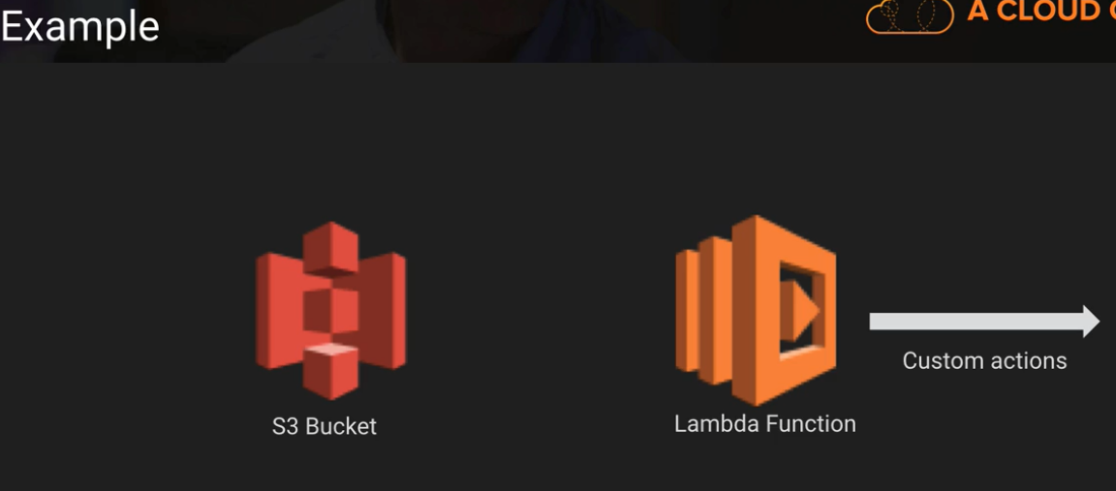

LAB – 0

